TASK – 1
Convert ER Diagram into Relational Model
AIM: To convert the given Entity-Relationship (ER) diagram into a relational model following standard database design mapping rules.
DIAGRAM:
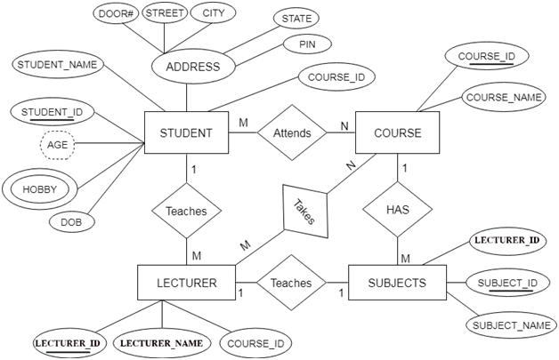
Steps for converting the ER diagram to the table
- Entity type becomes a table
each entity type in the ER diagram becomes a table in the relational model.
From the ER diagram, the main entity types are:
- STUDENT
- LECTURER
- COURSE
- SUBJECTS
Each of these will be represented as a separate table in your relational database design.
For example:
- The STUDENT entity becomes the STUDENT table.
- The LECTURER entity becomes the LECTURER table.
- The COURSE entity becomes the COURSE table.
- The SUBJECTS entity becomes the SUBJECT table.
Each table will then contain columns that represent that entity's attributes (fields such as STUDENT_ID, STUDENT_NAME for the STUDENT table, and so on).
STUDENT
Column Name | Description
STUDENT_ID | Primary Key
STUDENT_NAME | Student name
DOB | Date of birth
DOOR# | Address component
STREET | Address component
CITY | Address component
STATE | Address component
PIN | Address component
COURSE_ID | Foreign Key referencing COURSE

- All single-valued attribute becomes a column for the table.
Rule:
All single-valued attributes in the ER diagram become columns for the corresponding table in the relational model.
Application to Provided ER Diagram:
For each entity type, identify the single-valued attributes (those represented by ovals and directly connected to the entity, not multivalued or composite):
- STUDENT:
  - STUDENT_ID
  - STUDENT_NAME
  - DOB
  - COURSE_ID
- LECTURER:
  - LECTURER_ID
  - LECTURER_NAME
  - COURSE_ID
- COURSE:
  - COURSE_ID
  - COURSE_NAME
- SUBJECTS:
  - SUBJECT_ID
  - SUBJECT_NAME
  - LECTURER_ID
- ADDRESS (Composite, but components are single-valued):
  - DOOR#
  - STREET
  - CITY
  - STATE
  - PIN
  - COURSE
- Column Name | - Description
- COURSE_ID | - Primary Key
- COURSE_NAME | - Name of the course
. LECTURER
Column Name | Description
LECTURER_ID | Primary Key
LECTURER_NAME | Lecturer's name
COURSE_ID | Foreign Key referencing COURSE

- A key attribute of the entity type represented by the primary key.
Rule:
A key attribute of each entity type in the ER diagram is represented as the primary key in the corresponding table in the relational model.
Application to Provided ER Diagram:
For every entity:
- Identify the attribute that uniquely distinguishes each instance of that entity (usually underlined in the ER diagram).
- This attribute becomes the primary key for the table created for that entity.
Primary Keys for the Entities:
- STUDENT:
  - STUDENT_ID (Primary Key)
- LECTURER:
  - LECTURER_ID (Primary Key)
- COURSE:
  - COURSE_ID (Primary Key)
- SUBJECTS:
  - SUBJECT_ID (Primary Key)
SUBJECT
Column Name | Description
SUBJECT_ID | Primary Key
SUBJECT_NAME | Subject name
LECTURER_ID | Foreign Key referencing LECTURER

- The multivalued attribute is represented by a separate table
Rule:
A multivalued attribute is represented by a separate table in the relational model.
Application to Provided ER Diagram:
In your ER diagram, the entity STUDENT has a multivalued attribute: HOBBY.
Implementation:
- You create a new table (e.g., STUD_HOBBY) to represent the combination of the student and their hobbies.
- Each row in this new table links a student's primary key to one of their hobbies.
Table Structure Example:
STUDENT_ID (FK) | HOBBY
1001 | Drawing
1001 | Singing
1002 | Sports

- STUDENT_ID: Foreign Key referencing the STUDENT table.
- HOBBY: One hobby per row.
- Composite attribute represented by components
Rule:
A composite attribute is represented by its component attributes as individual columns in the table.
Application to Provided ER Diagram:
In your ER diagram, the ADDRESS attribute for the entity STUDENT is a composite attribute. It consists of the following simple attributes:
- DOOR#
- STREET
- CITY
- STATE
- PIN
Implementation:
- Instead of creating a single column for ADDRESS, you create separate columns for each of its components in the STUDENT table.
Resulting Columns in the STUDENT Table:
- DOOR#
- STREET
- CITY
- STATE
- PIN
- Derived attributes are not considered in the table

Rule:
Derived attributes are not considered in the table when converting an ER diagram to a relational model.
Application to Provided ER Diagram:
In your ER diagram, the attribute AGE for the entity STUDENT is shown as a derived attribute (usually denoted by a dashed oval). Derived attributes can be calculated from other data stored in the database (e.g., AGE can be derived from DOB).
Implementation:
- Do not create a column for derived attributes (like AGE) in the STUDENT table.
- Instead, derive such values using queries or calculations when needed, based on stored attributes like DOB.
RESULT:
Mapping/Relationships:
- STUDENT.COURSE_ID → COURSE.COURSE_ID (many students enroll in a course)
- LECTURER.COURSE_ID → COURSE.COURSE_ID (lecturers teach courses)
- SUBJECT.LECTURER_ID → LECTURER.LECTURER_ID (lecturers teach subject)
- STUD_HOBBY.STUDENT_ID → STUDENT.STUDENT_ID (students have multiple hobbies)

